***Name:Bijapure Naheen***

***R.No:08***

***Assignment No:01***

***Q1.***

***Use HTML5 new semantic elements to design different parts of a web page <article>, <aside>, <details>, <figcaption>, <figure>,<footer>,<header>,<main>,<mark>,<nav>,<section>,<summary>,<time>,<audio>,<video> <table>,<a>,<img>, <list>and any other elements required.***

***Ans:***

*<html>*

*<title>My First WebPage</title>*

*<head>*

*<style>*

*section{*

*display:block;*

*background-color:yellow;*

*text-align:center;*

*font-size:100%;*

*}*

*table,th,td{*

*border:1px solid black;*

*}*

*aside{*

*width:30%;*

*padding-left:15px;*

*margin-left:15px;*

*float:right;*

*font-style:italic;*

*background-color:lightgray;*

*}*

*main{*

*margin: 0;*

*padding: 5px;*

*background-color: lightgray;*

*}*

*mark{*

*background-color:yellow;*

*color:black;*

*font-style:italic;*

*}*

*</style>*

*<header>*

*<h1>Hello World</h1>*

*</head>*

*<body>*

*<p>This is a paragraph tag </p>*

*<p>Today is <time datetime="2022-09-09">Friday</time></p>*

*<p>Now the time is <time>08:11</time></p>*

*<table>*

*<tr>*

*<th>Name</th>*

*<th>Roll No</th>*

*<th>Gender</th>*

*</tr>*

*<tr>*

*<td>Riya Sharma</td>*

*<td>158</td>*

*<td>F</td>*

*</tr>*

*<tr>*

*<td>Amit Sharma</td>*

*<td>111</td>*

*<td>M</td>*

*</tr>*

*<hr>*

*<a href="https://classroom.google.com/c/NDk3ODQ4NzM4ODMz/a/NTQ0NzIzNTE3NTY4/details">Google Classroom</a>*

*<hr>*

*</table>*

*<hr>*

*<figure>*

*<img src="D:\BE_IT_08\cat.png" alt="Cat_Image " style="width:250px;height:250px;background-color:black;color:white;">*

*<figcaption><mark>Fig.1-Cat.</mark></figcaption>*

*</figure>*

*<hr>*

*<h3><mark>Department Names</mark></h3>*

*<ul>*

*<li>IT</li>*

*<li>CSE</li>*

*<li>E&Tc</li>*

*</ul>*

*<hr>*

*<h3><mark>Cafe Menu</mark></h3>*

*<ol type="A">*

*<li>Coffee</li>*

*<li>Tea</li>*

*<li>Milk</li>*

*</ol>*

*<hr>*

*<audio controls>*

*<source src="D:\BE_IT_08\music1.mp3" type="audio/mpeg">*

*</audio>*

*<hr>*

*<video width="300" height="300" controls>*

*<source src="D:\BE_IT_08\video1.mp4" type="video/mp4">*

*</video>*

*<hr>*

*<h1><mark>Article Tag<mark></h1>*

*<article>*

*<main>*

*<h2>Google Chrome</h2>*

*<p>Google Chrome is a web browser developed by Google, released in 2008. Chrome is the world's most popular web browser today!</p>*

*</main>*

*</article>*

*<article>*

*<main>*

*<h2>Mozilla Firefox</h2>*

*<p>Mozilla Firefox is an open-source web browser developed by Mozilla. Firefox has been the second most popular web browser since January, 2018.</p>*

*</main>*

*</article>*

*<article>*

*<main>*

*<h2>Microsoft Edge</h2>*

*<p>Microsoft Edge is a web browser developed by Microsoft, released in 2015. Microsoft Edge replace Internet Explorer.</p>*

*</main>*

*</article>*

*<hr>*

*<details>*

*<summary><mark>WIT Departments</mark></summary>*

*<ul>*

*<li>IT</li>*

*<li>CSE</li>*

*<li>Electronics</li>*

*<li>E&Tc</li>*

*<li>Civil</li>*

*<li>Mechanical</li>*

*</ul>*

*</details>*

*</header>*

*<footer>*

*<section>*

*<nav>*

*<b><i>*

*<p><a href="https://www.linkedin.com/in/naheen-bijapure-1176241a4">Naheen Bijapure</a></p>*

*<p><a href="https://mail.google.com/mail/u/0/#inbox">naheenbijapure094@gmail.com</a></p>*

*<p>+91-8815745696</p>*

*</i></b>*

*</nav>*

*</section>*

*</html>*

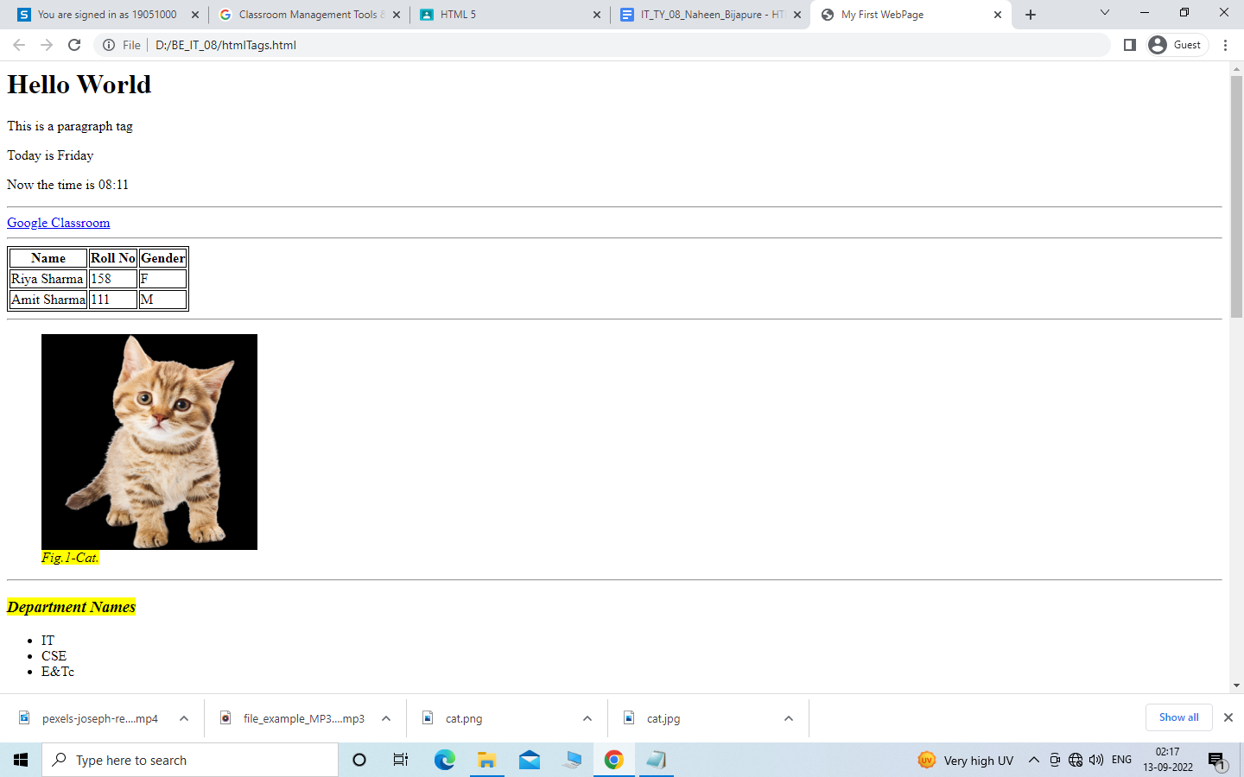

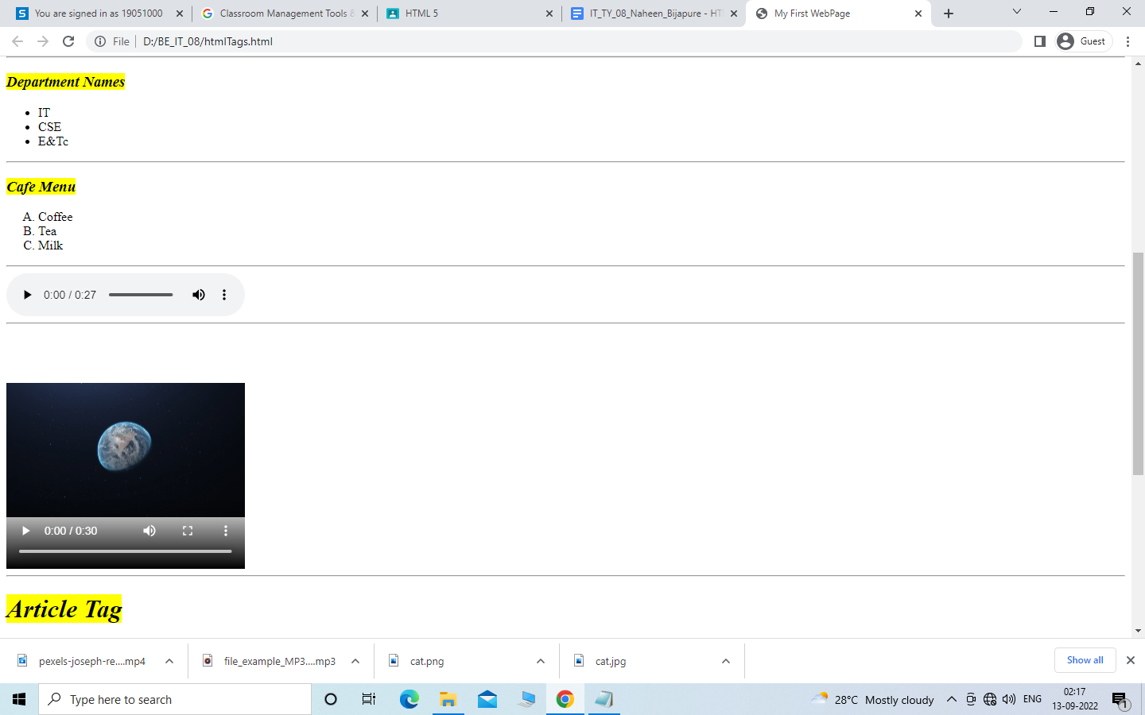

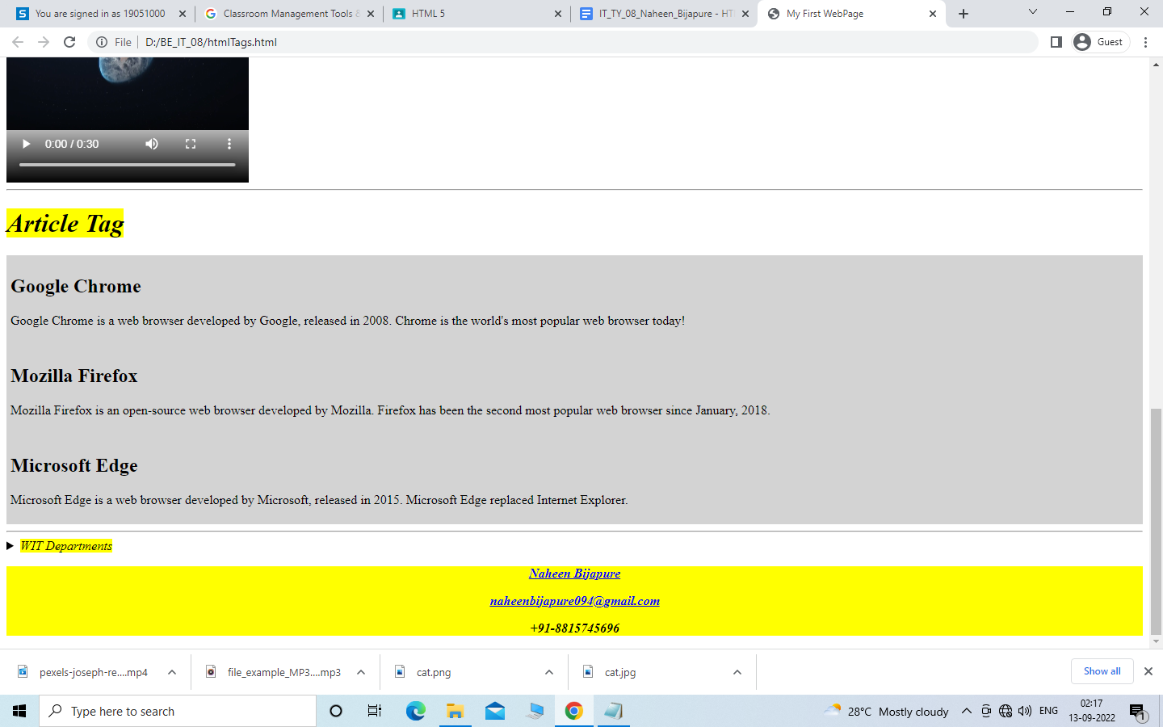

***Q2.***

***Design web pages for your college containing a description of the courses, departments, faculty, library etc. by using HTML5 – Semantic Tags***

***Ans:***

*<html>*

*<head>*

*<title>WIT</title>*

*<link rel="stylesheet" href="xyz.css" type="text/css">*

*<style type="text/css">*

*.vid{font-family:verdana;font-style:italic;color:red;text-align:center;font-size:40px;}*

*.ani{font-family:tahoma;font-style:italic;font-size:20;text-align:center;}*

*font{font-family:georgia;color:blue;font-size:20}*

*ul{list-style-type:circle}*

*mark{*

*background-color:yellow;*

*color:red;*

*}*

*</style>*

*</head>*

*<body style="background-color:#AEF7A6">*

*<br>*

*<h2 class="vid"><mark>Walchand Institute Of Technology,Solapur</mark></h2>*

*<p style="text-align:center;color:purple;font-size:30px">The Institute is affiliated to the Solapur University, Solapur and approved by the All India Council for Technical Education, New Delhi (A.I.C.T.E., New Delhi.).</p>*

*<br>*

*<img src="wit.jpg" alt="WIT" style="width:100%">*

*<br>*

*<ol style="list-style-type:lower-alpha">*

*<br>*

*<h2 style="color:red">GROUP OF COLLEGES</h2>*

*<details>*

*<summary></summary>*

*<br>*

*<li style="font-size:20px;">Walchand College Of Arts & Scince Solapur.*

*<li style="font-size:20px;">Walchand Institute Of Technology Solapur.*

*<li style="font-size:20px;">HN Commerce Solapur.*

*</ol>*

*</details>*

*<br>*

*<h2 style="color:red">Highlights</h2>*

*<ul style="list-style-type:square">*

*<li style="font-size:20px;color:black"><b>WIT makes it to TOP 200 Engineering Institutes in NIRF Rankings 2017</li>*

*<li style="font-size:20px;color:black"><b>WIT ranks 63rd in TIMES ENGINEERING INSTITUTE RANKING SURVEY 2018</li>*

*<li style="font-size:20px;color:black"><b>CII best industry industry linked institute 2013-14 and 2014-15.</li>*

*<li style="font-size:20px;color:black"><b>MOU with Infosys, awarded by Infosys as Best Institute for Industry Elective Rollout.</li>*

*<li style="font-size:20px;color:black"><b>Remote Center of IIT, Bombay and IIT, Kharaghpur.</li>*

*</ul>*

*<br>*

*<h3 style="color:red">List of Courses offered</h3>*

*<details>*

*<summary> </summary>*

*<ul>*

*<li>Computer Science and Engineering</li>*

*<li>Information Technology</li>*

*<li>E&Tc</li>*

*<li>Mechanical</li>*

*<li>Electronics</li>*

*<li>Civil</li>*

*</ul>*

*</details>*

*</body>*

*</html>*

***Output:***

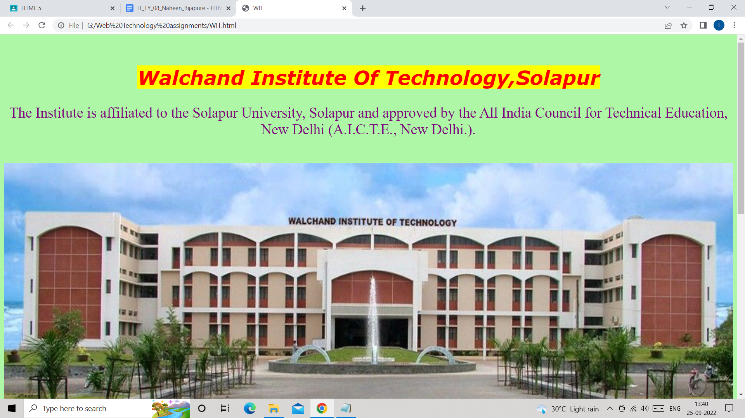

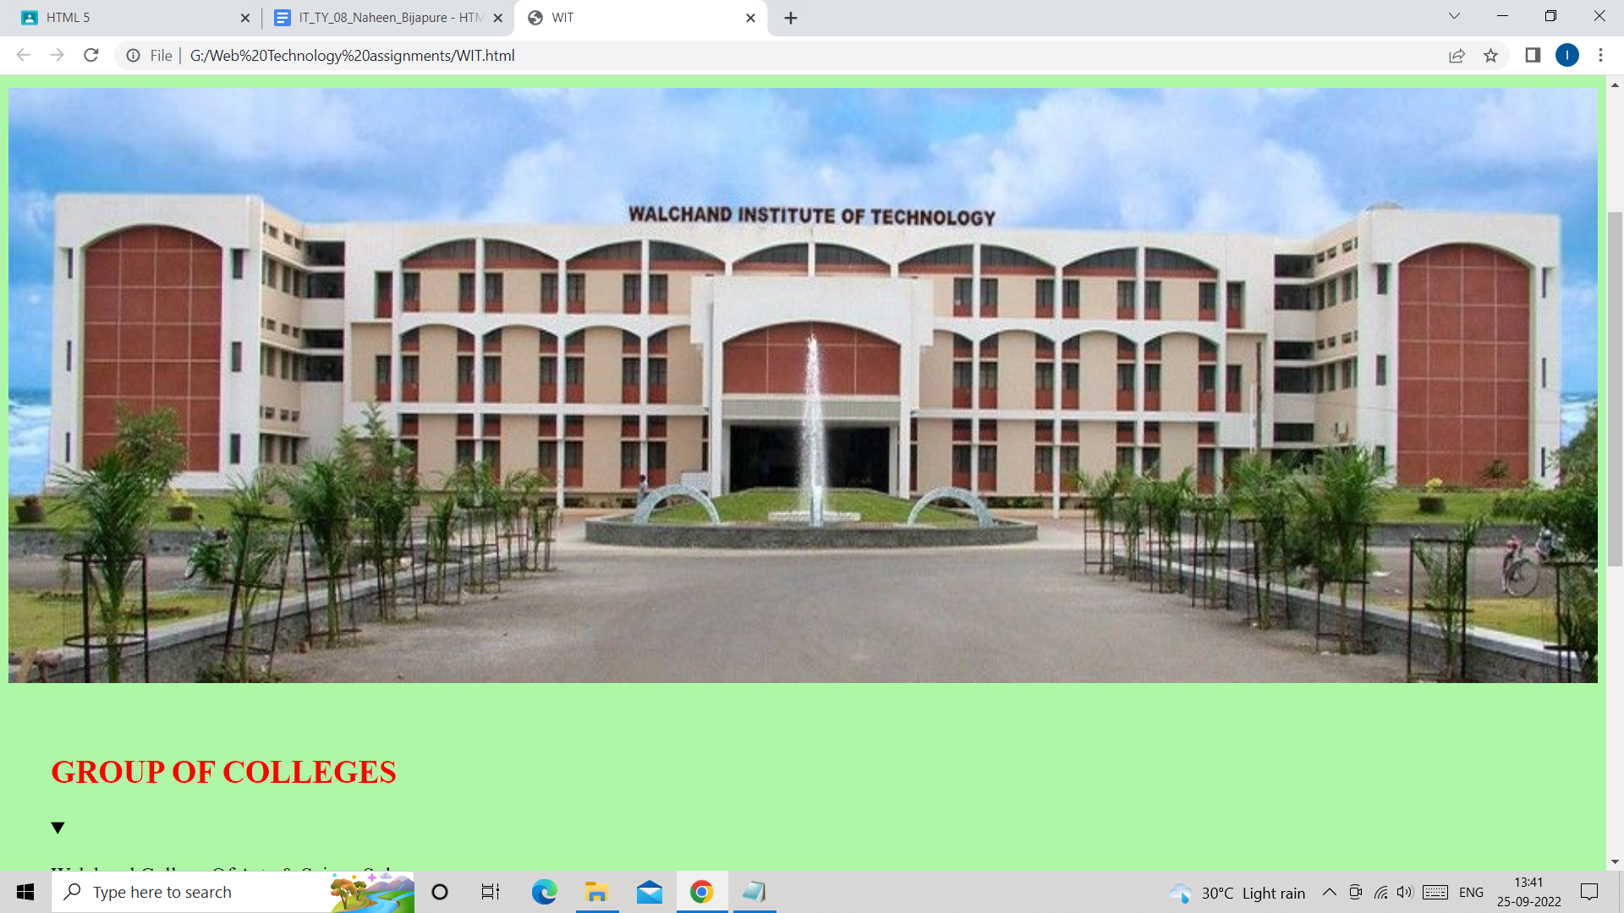

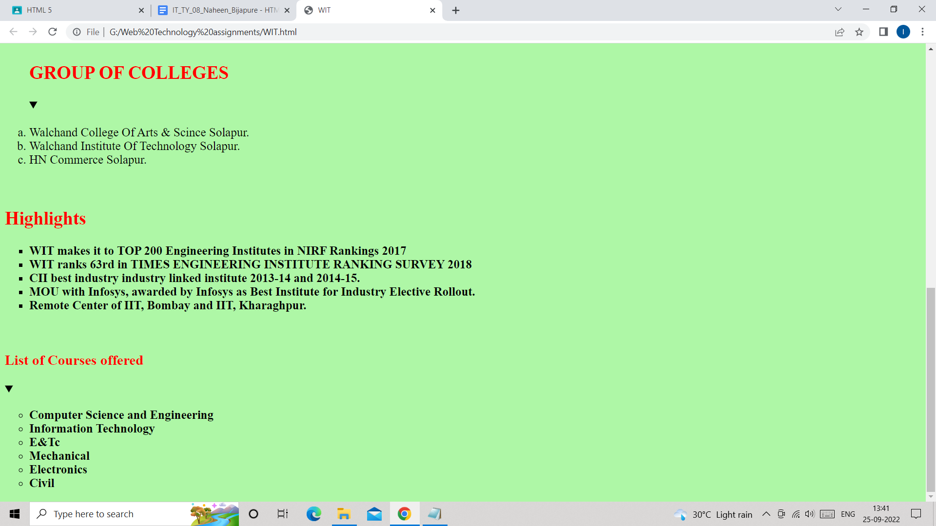

***Q3.***

***Create your resume using HTML 5 tags and also experiment with colors, text, link, size, and also other tags you studied.***

***Ans:***

***Resume.html:***

*<html lang="en">*

*<head>*

*<meta charset="UTF-8">*

*<meta http-equiv="X-UA-Compatible" content="IE=edge">*

*<meta name="viewport"*

*content="width=device-width, initial-scale=1.0">*

*<link rel="stylesheet" href="styling.css">*

*<style>*

*table, th, td {*

*border: 1px solid black;*

*border-radius: 10px;*

*border-color: #000000;*

*border-style:solid;*

*}*

*</style>*

*</head>*

*<body>*

*<div class="full">*

*<div class="left">*

*<div class="image">*

*<img src="profile.jpg"*

*alt="profile"*

*style="width:150px;height:150px;">*

*</div>*

*<div class="Contact">*

*<h2>Contact:</h2>*

*<p><b>Email-Id:</b><a href="https://mail.google.com/mail/u/0/#inbox" target="_blank">naheenbijapure094@gmail.com</a></p>*

*<p><b>Mobile no :</b>+91-8080157115</p>*

*<p><b>Linkdin-Id:</b><a href="https://www.linkedin.com/in/naheen-bijapure-1176241a4" target="_blank">Naheen Bijapure</a></p>*

*</div>*

*<div class="Skills">*

*<h2>Skills:</h2>*

*<ul>*

*<li><b>Programming Languages :*

*Python, Java, C</b></li>*

*<li><b>Frontend : HTML5, CSS3</b></li>*

*</ul>*

*</div>*

*<div class="Awards">*

*<h2>Awards/Certification:</h2>*

*<ul>*

*<li>completed Campus Ambassador Internship from Internmind company.</li>*

*<li>Completed Front-end Web development training from Bolt IoT Platform.</li>*

*<li>Certified for NPTEL courses like “Introduction to programming in C” & "Joy of Computing with Python" and also got a silver medal for "Joy of Computing with Python".</li>*

*<li>Certified for edx courses:*

*1)AI for everyone : Master the basics.*

*2)Introduction to data science.*

*3)Python basic for data science.*

*4) How to learn Online.*

*</li>*

*<li>Certified in Synfig 2D animation Competition,Hackathon</li>*

*<li>Completed Two Internshala trainings:*

*1)Android App Development Training &*

*2)Internship & Job preparation Training (Got free as a reward for my work in the ISP24 program.)</li>*

*</ul>*

*</div>*

*<div class="Language">*

*<h2>Language:</h2>*

*<ul>*

*<li>English</li>*

*<li>Urdu</li>*

*<li>Hindi</li>*

*<li>Marathi</li>*

*</ul>*

*</div>*

*<div class="Hobbies">*

*<h2>Hobbies:</h2>*

*<ul>*

*<li>Playing Cricket</li>*

*<li>Playing Batminton</li>*

*</ul>*

*</div>*

*<div class="References">*

*<h2>References:</h2>*

*<p>Naheen Bijapure</p>*

*<p>Student of WIT</p>*

*<p>naheenbijapure380@gmail.com</p>*

*<p>8080157115</p>*

*</div>*

*</div>*

*<div class="right">*

*<div class="name">*

*<h1>Naheen Bijapure</h1>*

*</div>*

*<div class="title">*

*<p>Quick Learner,Enthusiastic to learn new things,Problem Solver.</p>*

*</div>*

*<div class="Education">*

*<h2>Education:</h2>*

*<table>*

*<tr>*

*<th>Degree/Grade</th>*

*<th>Institution</th>*

*<th>Year</th>*

*<th>Score</th>*

*</tr>*

*<tr>*

*<td>B.Tech(IT)-TE</td>*

*<td>Walchand Institute of Technology,Solapur</td>*

*<td>2021-2022</td>*

*<td>Percentage:94.35% SGPA:10.00</td>*

*</tr>*

*<tr>*

*<td>B.Tech(IT)-SE</td>*

*<td>Walchand Institute of Technology,Solapur</td>*

*<td>2020-2021</td>*

*<td>Percentage:90.5% SGPA: 9.965</td>*

*</tr>*

*<tr>*

*<td>B.Tech(IT)-FE</td>*

*<td>Walchand Institute of Technology,Solapur</td>*

*<td>2019-2020</td>*

*<td>Percentage:92.07% SGPA: 10.00</td>*

*</tr>*

*<tr>*

*<td>HSC</td>*

*<td>S.S.A Urdu High School & Jr. College Of Science,Solapur</td>*

*<td>2018-2019</td>*

*<td>Percentage:84.91% CET: 93.10 percentile JEE: 67 Percentile</td>*

*</tr>*

*<tr>*

*<td>SSC</td>*

*<td>S.S.A Urdu High School & Jr. College Of Science,Solapur</td>*

*<td>2016-2017</td>*

*<td>Percentage: 94.40% Mathematics paper marks: 100/100.</td>*

*</tr>*

*</table>*

*</div>*

*<div class="Experience">*

*<h2>Experience:</h2>*

*<br>*

*<ul style="list-style-type:disk;">*

*<li><h3>My first Internship as a volunteer:</h3>*

*<p>I have completed my first internship as a volunteer in my Second Year of B.Tech. It was an unpaid internship offered by Team Everest(NGO).You can refer to my Linkedin profile for more details.</p>*

*</li>*

*<li>*

*<h3>My first Technical Internship(From Bolt IoT Platform):</h3>*

*<p>I have also completed my first Technical Internship on Web Development offered by Bolt IoT platform .You can refer to my Linkedin profile for more details.</p>*

*</li>*

*<li>*

*<h3>Participated in ISP24 program of Internshala:</h3>*

*<p>I have also participated in the ISP24 program of Internshala and worked as an ISP for 1 month. I have also got a free training from Internshala as a reward for my work in ISP24.You can refer to my Linkedin profile for more details.</p>*

*</li>*

*<li>*

*<h3>My second Technical Internship(From Oasis Infobyte):</h3>*

*<p>I have completed my second internship on Android App development offered by Oasis Infobyte company.You can refer to my Linkedin profile for more details.</p>*

*</li>*

*</ul>*

*</div>*

*<div class="project">*

*<h2>Projects:</h2>*

*<br>*

*<ul>*

*<li>*

*<h2>C Language Based Quiz(self learning):</h2>*

*<p>When I was in second year of my B.Tech course, I had completed one mini project.In this project I had created a quiz based on my C language knowledge.In this project I had used do while loop to display questions repeatedly.As in first year I had studied only C language so by using My knowledge of C concepts, I tried to develop a “ C Language knowledge based quiz”.</p>*

*</li>*

*<li>*

*<h2>Simple Calculator App:</h2>*

*<p>I have created one simple calculator app which performs different mathematical operations like addition,subtraction,multiplication,division etc.</p>*

*</li>*

*<li>*

*<h2>Unit Converter App:</h2>*

*<p>I have created one app which converts the value of one unit into another like it converts KG to Grams,Grams to KG,Meter to Cm & Cm to Meter.</p>*

*</li>*

*<li>*

*<h2>Mini project (In Group)-TechCare App:</h2>*

*<p>In this semester I am doing a mini-project in group.In this Mini project we have developed an android app which can measure different body vitals like heart rate, spo2, respiration rate & Blood pressure just by using an android phone, without any body vitals measuring device.</p>*

*</li>*

*</ul>*

*</div>*

*</div>*

*</div>*

*</body>*

*</html>*

***Styling.css:***

*/* Write CSS Here */*

*\* {*

*margin: 0;*

*padding: 0;*

*box-sizing: border-box;*

*}*

*body {*

*background-color: rgb(253, 254, 255);*

*display: flex;*

*justify-content: center;*

*align-items: center;*

*}*

*.full {*

*width: 50%;*

*max-width: 1000px;*

*min-height: 100px;*

*background-color:rgb(245, 239, 231);*

*margin: 0px;*

*display: grid;*

*grid-template-columns: 2fr 4fr;*

*}*

*.left {*

*position: initial;*

*background-color: rgb(126, 219, 231);*

*padding: 20px;*

*}*

*.right {*

*position: initial;*

*background-color: rgb(162, 202, 206);*

*padding: 20px;*

*}*

*.image, .Contact, .Skills, .Language, .Hobbies, .title,*

*.Summary, .Experience, .Education, .project {*

*margin-bottom: 30px;*

*}*

*.h2 {*

*background-color: rgb(4, 96, 150);*

*}*

***Output:***

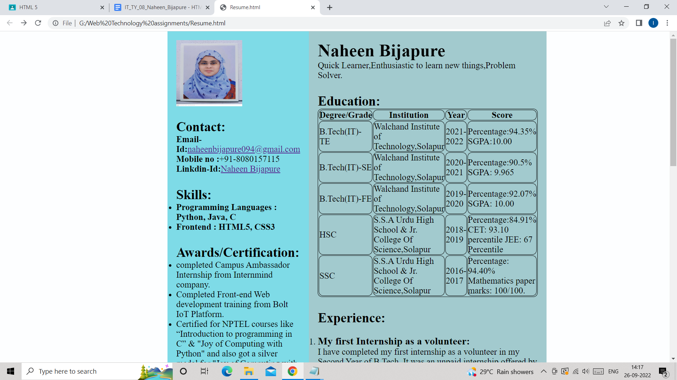

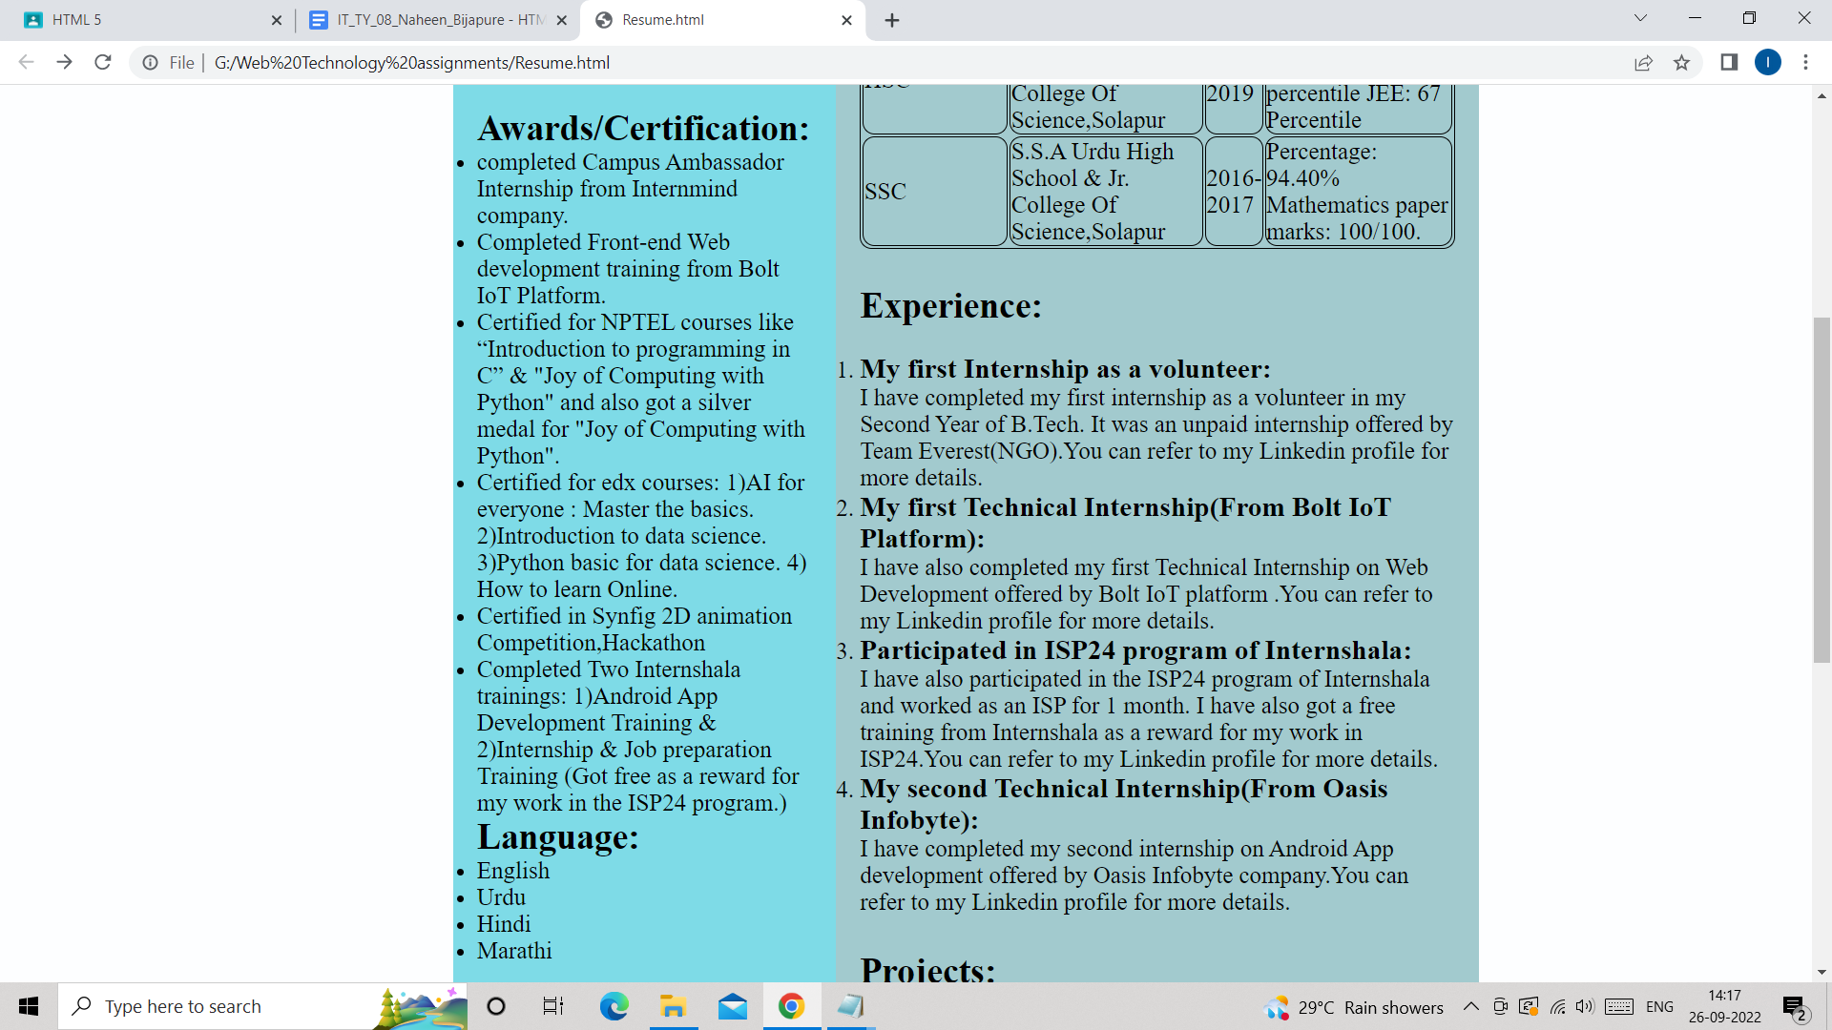

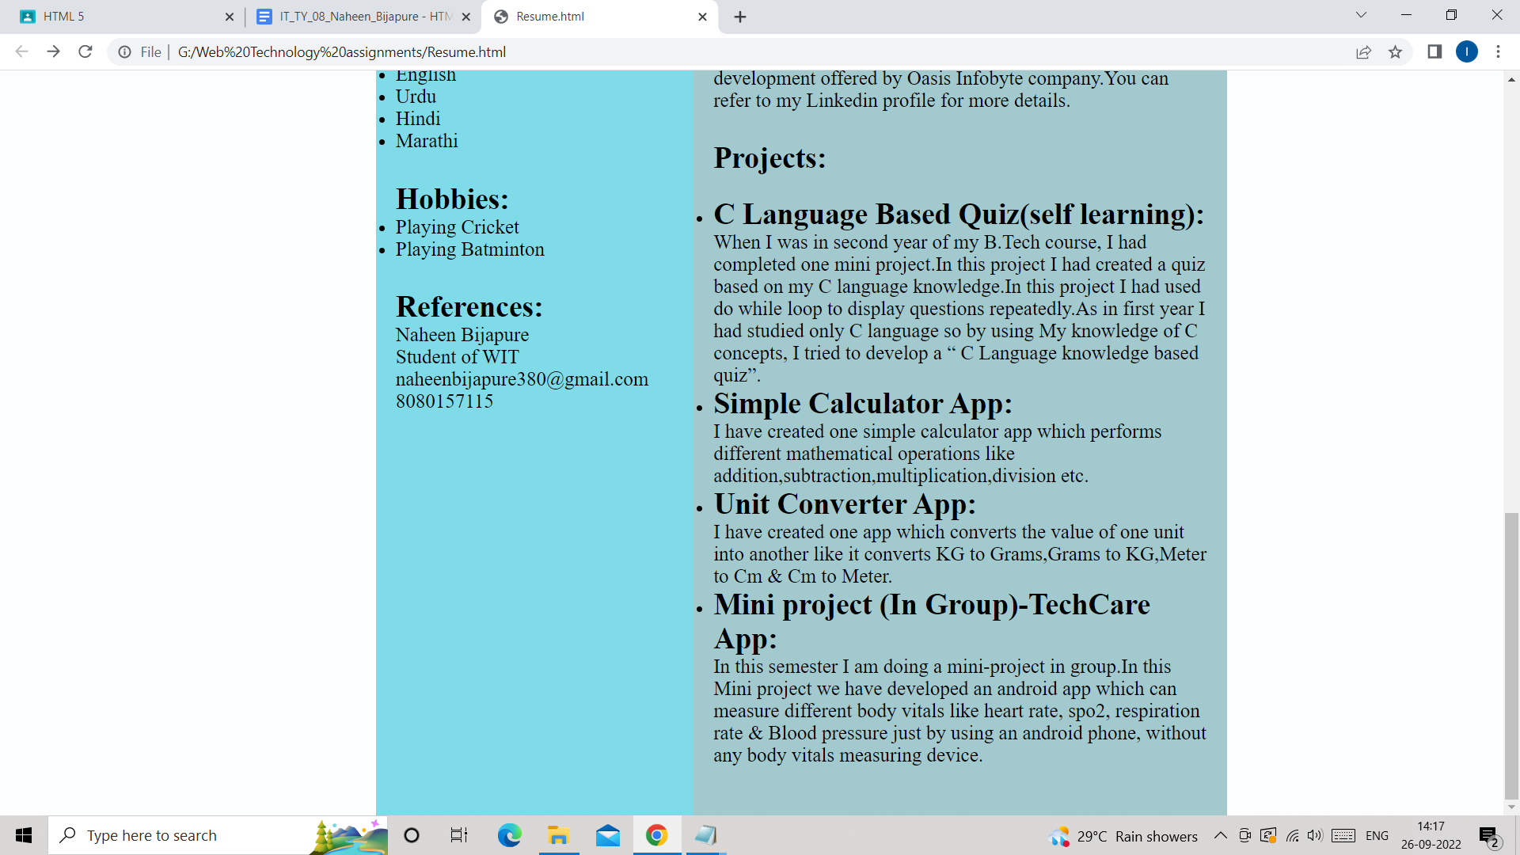

***Q4.Draw graphics on a web page using the HTML5 canvas element.***

***Ans:***

*<!DOCTYPE html>*

*<html>*

*<body>*

*<canvas id="myCanvas" width="200" height="100" style="border:1px solid #000000;">*

*Your browser does not support the HTML canvas tag.</canvas>*

*<script>*

*var c = document.getElementById("myCanvas");*

*var ctx = c.getContext("2d");*

*ctx.beginPath();*

*ctx.arc(95,50,40,0,2*Math.PI);*

*ctx.stroke();*

*</script>*

*<script>*

*var c = document.getElementById("myCanvas");*

*var ctx = c.getContext("2d");*

*ctx.moveTo(0, 0);*

*ctx.lineTo(200, 100);*

*ctx.stroke();*

*</script>*

*<script>*

*var c = document.getElementById("myCanvas");*

*var ctx = c.getContext("2d");*

*ctx.moveTo(200, 0);*

*ctx.lineTo(0, 100);*

*ctx.stroke();*

*</script>*

*</body>*

*</html>*

***Output:***

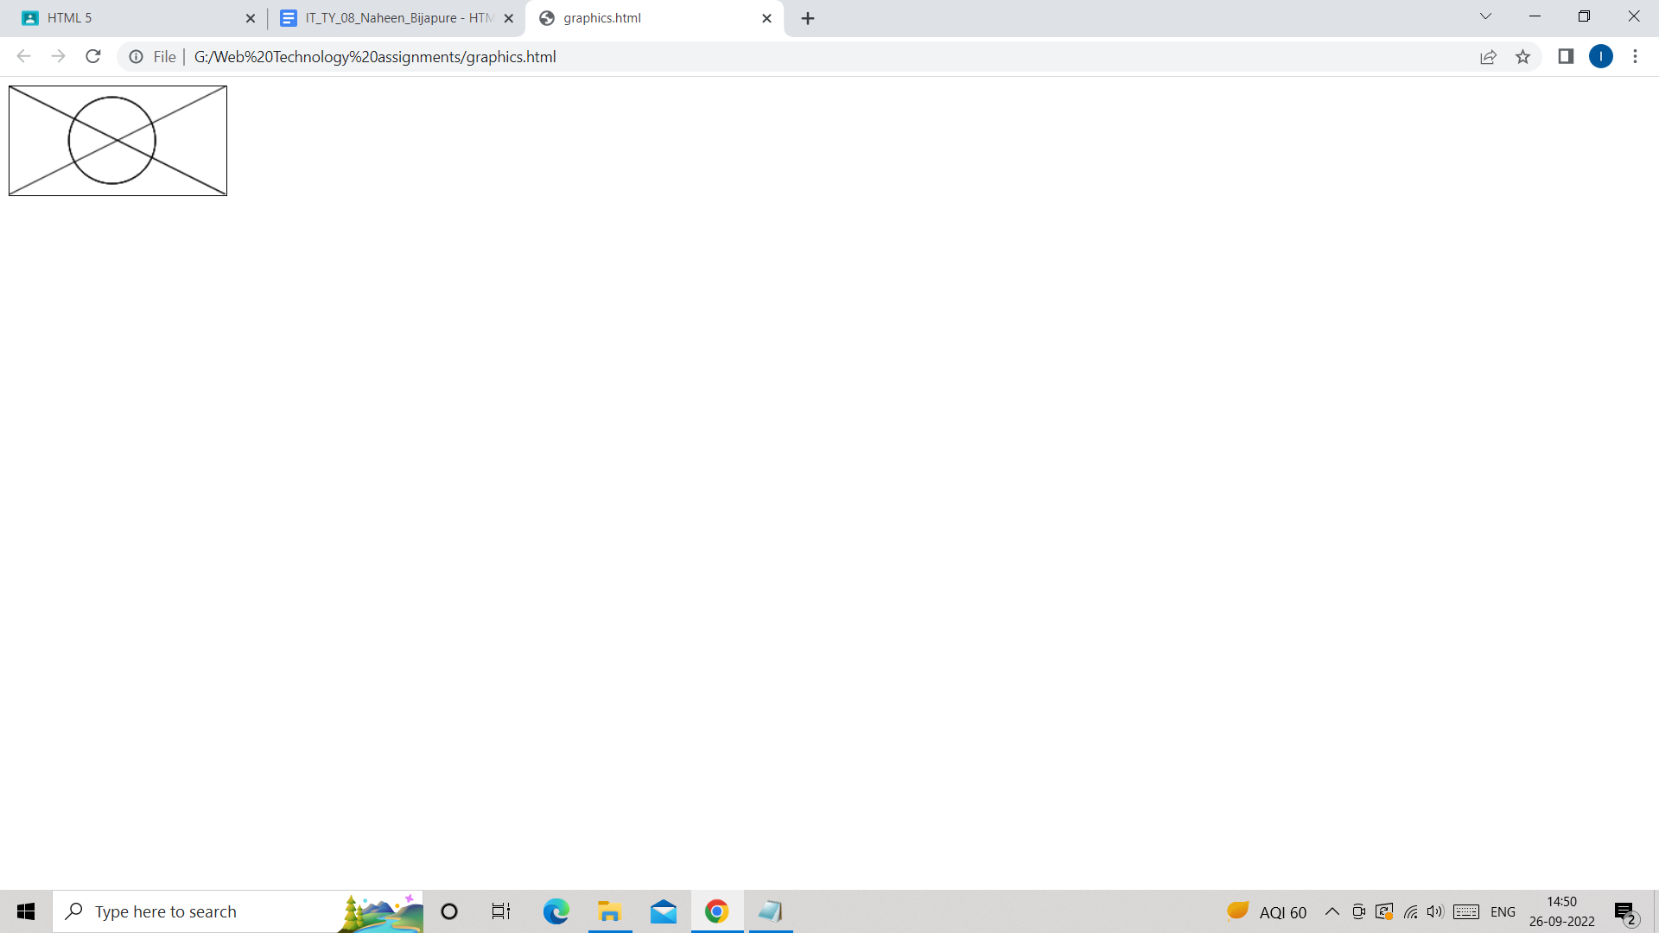

***Q5.Use the HTML5 Geolocation feature to detect the user's location.***

***Ans:***

*<!DOCTYPE html>*

*<html>*

*<body>*

*<p>Click the button to get your coordinates.</p>*

*<button onclick="getLocation()">Try It</button>*

*<p id="demo"></p>*

*<script>*

*var x = document.getElementById("demo");*

*function getLocation() {*

*if (navigator.geolocation) {*

*navigator.geolocation.getCurrentPosition(showPosition);*

*} else {*

*x.innerHTML = "Geolocation is not supported by this browser.";*

*}*

*}*

*function showPosition(position) {*

*x.innerHTML = "Latitude: " + position.coords.latitude +*

*"<br>Longitude: " + position.coords.longitude;*

*}*

*</script>*

*</body>*

*</html>*

***Output:***

